**Title: Lab Work 2**

*Course title: Computer Graphics Laboratory*

*Course code: CSE-304*

*3rd Year 1st Semester Examination 2022*

**Date of Submission**: 4 June 2023



**Submitted to-**

**Dr. Mohammad Shorif Uddin**

*Professor*

*Department of Computer Science and Engineering*

*Jahangirnagar University*

*Savar, Dhaka-1342*

**Dr. Morium Akter**

*Associate Professor*

*Department of Computer Science and Engineering*

*Jahangirnagar University*

*Savar, Dhaka-1342*

|  |  |  |  |
| --- | --- | --- | --- |
| **Sl** | Class Roll | Exam Roll | Name |
| 01 | 361 | 202173 | Mahiyat Tanzim |

**Scan Convert a Circle (Midpoint Algorithm):**

**Source Code**

#include<stdio.h>

#include<math.h>

#include<graphics.h>

int main()

{

int x,y,p,r,h,k;

//double x,y;

printf("Enter the coordinates of the center: ");

scanf("%d%d",&h,&k);

printf("Enter the radius of the circle: ");

scanf("%d",&r);

x=0;

y=r;

p=1-r;

initwindow(1000,600);

while(x<=y)

{

putpixel(x+h,y+k,LIGHTBLUE);

putpixel(y+h,x+k,LIGHTBLUE);

putpixel(-y+h,x+k,LIGHTBLUE);

putpixel(-x+h,y+k,LIGHTBLUE);

putpixel(-x+h,-y+k,LIGHTBLUE);

putpixel(-y+h,-x+k,LIGHTBLUE);

putpixel(y+h,-x+k,LIGHTBLUE);

putpixel(x+h,-y+k,LIGHTBLUE);

if(p<0)p+=(2*x+3);

else

{

p+=(2*(x-y)+5);

y--;

}

x++;

}

getch();

return 0;

}

**Screenshot:**

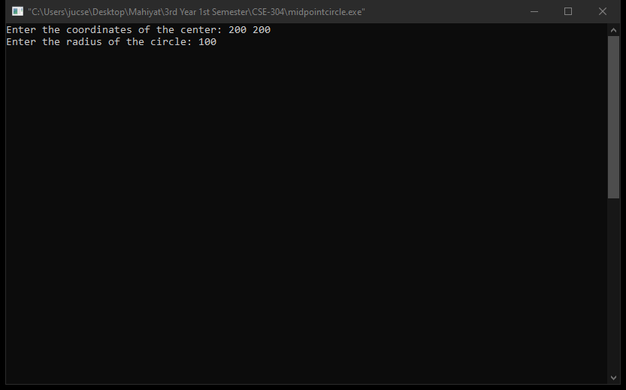

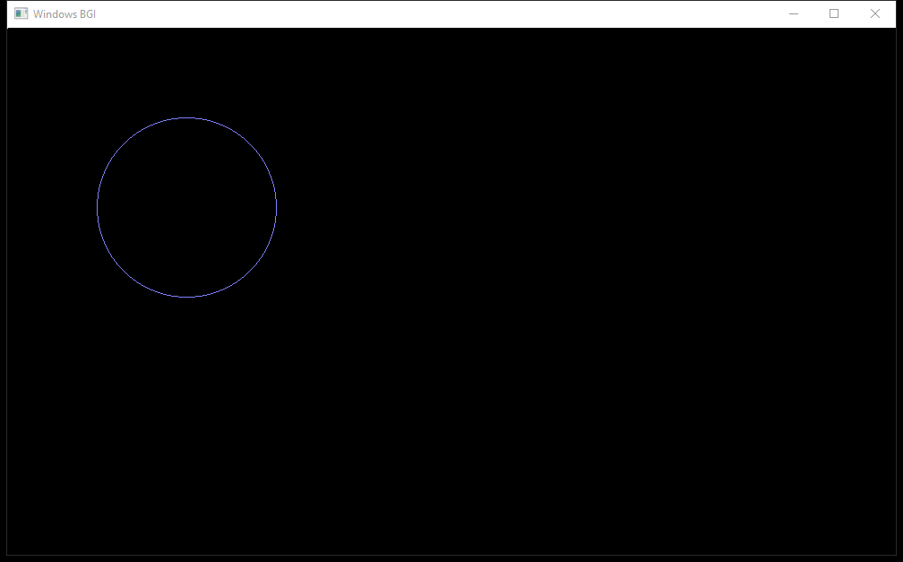

**Scan Convert an Ellipse (Midpoint Algorithm):**

**Source Code:**

#include<stdio.h>

#include<math.h>

#include<graphics.h>

int main()

{

int x,y,p,h,k,a,b,fx,fy;

printf("Enter the coordinates of the center: ");

scanf("%d%d",&h,&k);

printf("Enter the lengths of major and minor axes: ");

scanf("%d%d",&a,&b);

x=0;

y=b;

fx=0;

fy=2*b*a*a;

p=b*b-a*a*b+0.25*a*a;

initwindow(1000,600);

while(fx<fy)

{

putpixel(x+h,y+k,LIGHTBLUE);

putpixel(-x+h,y+k,LIGHTBLUE);

putpixel(-x+h,-y+k,LIGHTBLUE);

putpixel(x+h,-y+k,LIGHTBLUE);

x++;

fx+=(2*b*b);

if(p<0)p+=(fx+b*b);

else

{

y--;

fy-=(a*a*2);

p+=(fx+b*b-fy);

}

}

putpixel(x+h,y+k,LIGHTBLUE);

putpixel(-x+h,y+k,LIGHTBLUE);

putpixel(-x+h,-y+k,LIGHTBLUE);

putpixel(x+h,-y+k,LIGHTBLUE);

p=b*b*(x+0.5)*(x+0.5)+a*a*(y-1)*(y-1)-a*a*b*b;

while(y>0)

{

y--;

fy-=(a*a*2);

if(p>=0)

{

p-=(fy+a*a);

}

else

{

x++;

fx+=(2*b*b);

p+=(fx-fy+a*a);

}

putpixel(x+h,y+k,LIGHTBLUE);

putpixel(-x+h,y+k,LIGHTBLUE);

putpixel(-x+h,-y+k,LIGHTBLUE);

putpixel(x+h,-y+k,LIGHTBLUE);

}

getch();

return 0;

}

**Screenshot:**

